Mtest Test Flow & Service Callback Flow

文件狀態  [ ] 草稿文件  [ ] 正式文件  [√ ] 更改正式文件 | 版 本： | Version 1.3
文件狀態  [ ] 草稿文件  [ ] 正式文件  [√ ] 更改正式文件 | 作 者： | Edwin
文件狀態  [ ] 草稿文件  [ ] 正式文件  [√ ] 更改正式文件 | 完 成 日期： | 14/12/2020

版本/狀態 | 作者 | 審核 | 完成日期 | 備註
Version1.0 | Edwin |  | 20/11/2020 | 初版
Version1.1 | Edwin |  | 01/12/2020 | 更新Auto Test Flow
Version1.2 | Edwin |  | 09/12/2020 | 新增Thermal Test & Boot Stable Test
Version1.3 | Edwin |  | 14/12/2020 | 新增Reset Default Test

subScribeEvent()
Add to
Event Map List
getListenerMap ()
Event ID , Listener
unsubScribeEvent()
Remove from
Event Map List
getListenerMap ()
Event ID , Listener
HiDtvActivity
1. onCreate ()

2. onResume ()

3. onPause ()
MainActivity
Call each
registCallback()
gMtestListener
Call each
unregistCallback()
HisiTVActivity
UnSubScribeEvent()
SubScribeEvent()
gMtestListener

getInstance ()
Set Callback
IDtvServiceCallback.Stub
hwNotify() { … }
Event Map List
EventHandler
Get Listener from Event Map List (by Event ID)
Event ID, …
Send Message
Service Callback 的flow
new Callback

AutoTest Flow , update UI ( V / X )
PesiSharedPreference
Default
Test Results

updateTestResultDisplay()
update UI ( V / X )
( THERMAL_TEST == 1 )
Or ( LONG_TERM_TEST == 1 ) ?
No
onCreate()
onResume ()
ThermalTest()
Yes
AutoTest()
1. LED ON/OFF
上下鍵操作LED顏色
LedModule , setWhite()
LedModule , setRed()

2. Power Saving
綠鍵啟用PowerModule , shutdown()
Power鍵啟動STB
Pass按藍鍵, Fail按紅鍵
更新Test Result

手動測試
POWER_TEST == 0 ?
PesiSharedPreference
Default
Test Results
PesiSharedPreference
HwTestConfig
- POWER_TEST
- THERMAL_TEST
- LONG_TERM_TEST
- ...

Yes
mCheckStatusRunnable
USB內有檢查到mtest_ini.dat
自動測試
updateTestResultDisplay()
update UI ( V / X )
按back回MainActivity
執行onResume

No
3. Front Panel
onMessage()收到下列message
KEY_POWER, KEY_CH_UP, KEY_CH_DOWN

讀取 Test Results
更新Test Result

更新Test Result

更新所有flag

讀取Flags

讀取Flags

更新Test Result

讀取 Test Results

讀取Flags , Test Results

AutoTest
SharedPreferences:
1. Default (Test Result)
2. HwMtestConfig (Flag)
Check Flash

On
Check DDR

On
Check WIFI

No

Yes
Check Bluetooth

No

Yes
Yes

Check Tuner
Read Test Result & Flag
Not Pass
Update Test Result

Check HDCP

Check USB
Pass

No
Check SD card
Check Ethernet

No

Yes
Pass
Not Pass
Yes
No

AutoTest()

Test Result not Pass

Test Result not Pass
Update Test Result

USB_TEST ON or
Test Result not Pass

Update Test Result
SD_TEST ON or
Test Result not Pass

Update Test Result
ETHERNET_TEST ON or
Test Result not Pass

Update Test Result

BT_TEST ON or
Test Result not Pass

Update Test Result
WIFI_TEST ON or
Test Result not Pass

Update Test Result

FLASH_TEST ON ?

OFF
Pass count (write to HwMtestConfig)
Pass count (write to HwMtestConfig)
Update Test Result
Off

DDR_TEST ON ?

Update Test Result
End

Thermal Test / Long Term Test
Thermal Test和Long Term Test做的事幾乎一樣，差異在Long Term Test多了紀錄log的功能
更新

更新

更新

更新

更新

更新

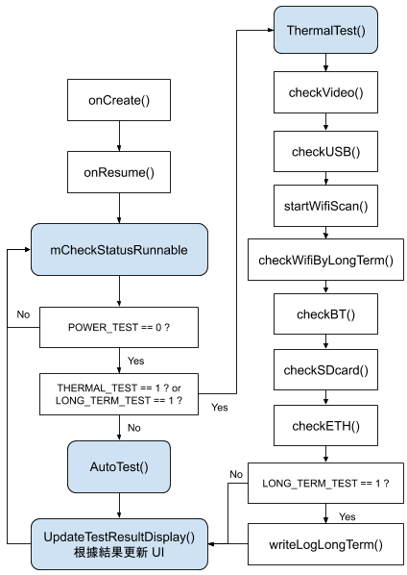
PesiSharedPreference
Default
Test Results

Boot Stable Test (Power On/Off Test)
PesiSharedPreference
Default
Test Results

更新

更新

更新

更新

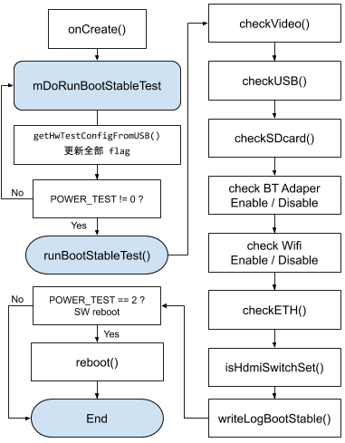
/* POWER_TEST
0:off
1:Tool, Production mode
2:SW reboot
3:STR
4:Reset Default Test */
1: Tool, Production mode | 靠製具timer測試，timer時間歸0後重開機
2:SW reboot | 無製具測試時，靠Intent.ACTION_REBOOT重開機
3:STR | 無製具測試時，以standby替代reboot
4:Reset Default Test | 測試Reset Default次數

Reset Default Test
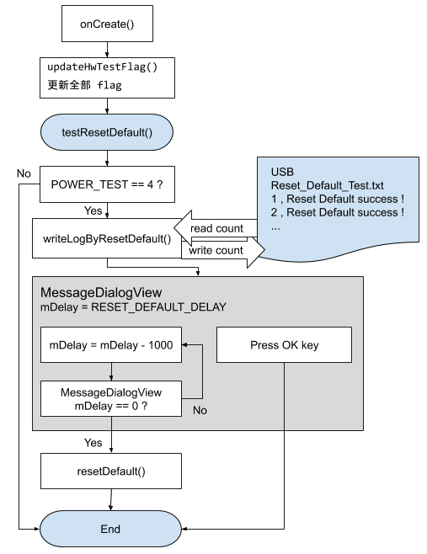
/* POWER_TEST
0:off
1:Tool, Production mode
2:SW reboot
3:STR
4:Reset Default Test */
1: Tool, Production mode | 靠製具timer測試，timer時間歸0後重開機
2:SW reboot | 無製具測試時，靠Intent.ACTION_REBOOT重開機
3:STR | 無製具測試時，以standby替代reboot
4:Reset Default Test | 測試Reset Default次數

